金属件产品/ Steel Products |  | 导轨异型扣系列/ E/A/L Track Fitting
款 号/ Item No. |  | F1017-4
General Description
Brand Name | RY
Item Name | 2” Spring E Track Fitting with U Hook
Item Number | F1017-4
Place of Origin | Jiangxi, China
Certification | ISO9001
Business Terms
Material | Carbon Steel
Process | Stamping
Finishing | Zinc Plating
Colour | Clear Zinc\ Yellow Zinc
MBS | 2045kgs/4500lbs
Unit Weight | 400g
MOQ | 1000pcs
Price | Negotiable
Lead Time | Within 45days
Payment | T/T with 30% deposit, L/C at sight
Port | Ningbo/ Shanghai
Supply Ability | One million per year
尺 寸 | 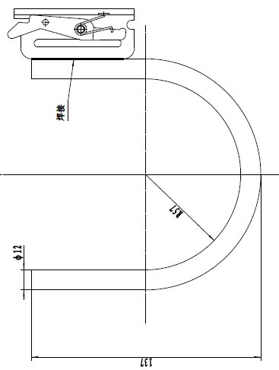
Size
APPLICATION FIELDS:
The 2” spring E track fitting is the basic styling for E track rail, to create a great solution for numerous anchor points to be used to keep cargo secured during the transport. This 2” spring fitting can be combined with many kinds of J hook, U hook, long screw and straps, to form a useful, practical, and durable track accessory with strength. In different styling, this fitting has a safe working load of 1500lbs, and break strength of over 4500lbs, which can be used as a versatile tie down anchor point for wide range of cargo in transport and storage.
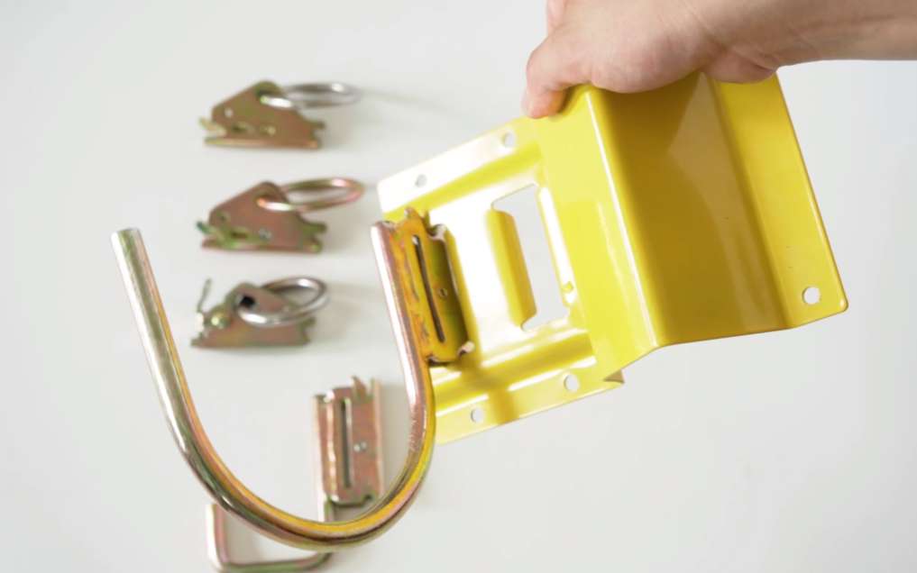

TECHNICAL FEATURE:
- Made of 1045# steel, by production technology of stamping.
- 1350lbs working load limit, and 4500lbs breaking strength.
- Galvanized finishing protect the parts from rust and corrosion.
- 2” spring E track fitting with U hook is perfect for hanging some large cargo in the trailer.
- Easy to use: clip on the track fitting in any slot of the rail, move and remove as you want.

PARTS OF SERIES:
- We provide a series of track fitting: single stud fitting, double stud fitting, E/A/L track fitting, with different dimension and different break strength to suit wide-range of application.
- Welcome customization according to your drawing or sample.
- E-track is available if you need, combining with the track fitting to create an organization system for transportation vehicle, garage, etc.
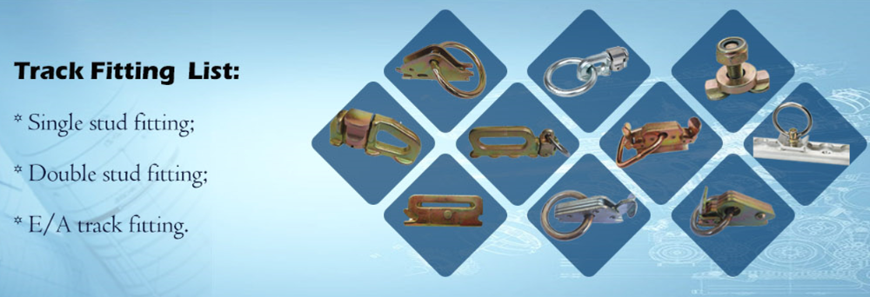

COMPANY ADVANTAGE:
Our factory have been specialized in the cargo control equipment for nearly 20 years, our main products includes all kinds of fasteners, ratchet buckles, hardware, automotive hand tools, rubber and plastic parts, etc, which are widely used in trucks and other transportation equipment. We have 6 workshops: forging, stamping, heat treatment, welding, precise processing, and assembly workshops. Over years of development, we have achieved annual productivity 7 million pieces, with daily productivity 30000pcs, passed through ISO9001 quality management system certification.

PRODUCT PACKAGING:
- Packed in cartons, and shipped in pallets, also support to customer’s other requirements.
- Gross weight of each carton is no more than 20kgs, providing friendly weight to workers for moving.
